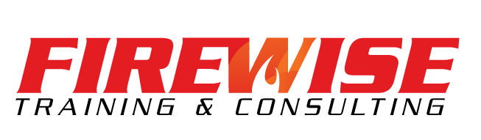

***Flight Crew Safety Training***

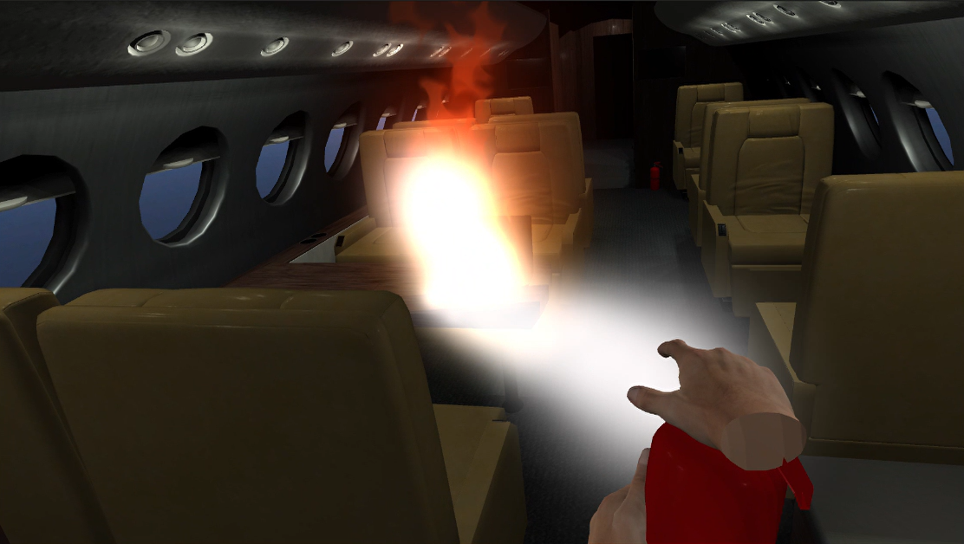

***Virtual Reality Fire Training!***

* **Scenarios include lap top fire, galley fire, cargo fire**
* **Timed**
* **Sounds and effects**

**Sterling Aviation Services and Firewise are recognized leaders in the aviation training industry, and have joined together to provide a full suite of training programs to meet your needs.**

**MEETS ALL TRANSPORT CANADA AND AOHS REQUIREMENTS**

***To register please contact firewise@sterlinginflight.com***